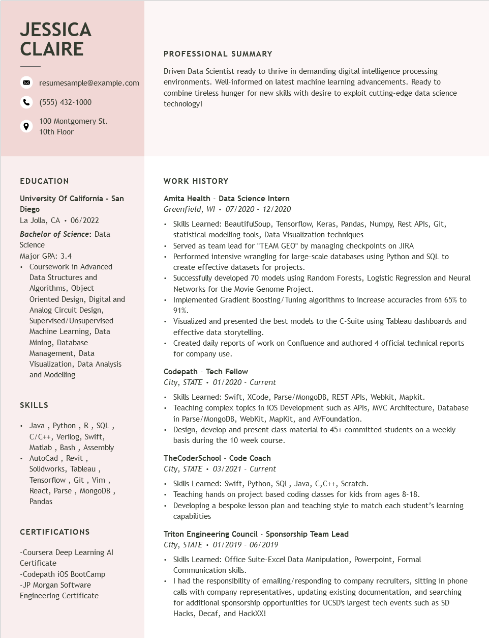
JESSICA CLAIRE
resumesample@example.com
(555) 432-1000
100 Montgomery St. 10th Floor
PROFESSIONAL SUMMARY
Driven Data Scientist ready to thrive in demanding digital intelligence processing environments. Well-informed on latest machine learning advancements. Ready to combine tireless hunger for new skills with desire to exploit cutting-edge data science technology!
EDUCATION
University of California - San Diego
La Jolla, CA 06/2022
Bachelor of Science: Data Science
Major GPA: 3.4
• Coursework in Advanced
Data Structures and Algorithms, Object
Oriented Design, Digital and Analog Circuit Design, Supervised/Unsupervised Machine Learning, Data Mining, Database Management, Data
Visualization, Data Analysis and Modelling
SKILLS
Java, Python, R, SQL, C/C++, Verilog, Swift, Matlab, Bash, Assembly AutoCad, Revit, Solidworks, Tableau,
Tensorflow, Git, Vim,
React, Parse, MongoDB, Pandas
CERTIFICATIONS
-Coursera Deep Learning Al
Certificate
-Codepath iOS BootCamp -JP Morgan Software
Engineering Certificate
WORK HISTORY
Amita Health - Data Science Intern Greenfield, WI 07/2020 - 12/2020
• Skills Learned: BeautifulSoup, Tensorflow, Keras, Pandas, Numpy, Rest APIs, Git, statistical modelling tools, Data Visualization techniques
Served as team lead for "TEAM GEO" by managing checkpoints on JIRA
• Performed intensive wrangling for large-scale databases using Python and SQL to create effective datasets for projects.
• Successfully developed 70 models using Random Forests, Logistic Regression and Neural Networks for the Movie Genome Project.
Implemented Gradient Boosting/Tuning algorithms to increase accuracies from 65% to 91%.
• Visualized and presented the best models to the C-Suite using Tableau dashboards and effective data storytelling.
• Created daily reports of work on Confluence and authored 4 official technical reports for company use.
Codepath - Tech Fellow
City, STATE 01/2020 - Current
• Skills Learned: Swift, XCode, Parse/MongoDB, REST APIs, Webkit, Mapkit.
Teaching complex topics in iOS Development such as APIs, MVC Architecture, Database in Parse/MongoDB, WebKit, MapKit, and AVFoundation.
• Design, develop and present class material to 45+ committed students on a weekly basis during the 10 week course.
TheCoderSchool - Code Coach City, STATE 03/2021 - Current
• Skills Learned: Swift, Python, SQL, Java, C, C++, Scratch.
Teaching hands on project based coding classes for kids from ages 8-18.
• Developing a bespoke lesson plan and teaching style to match each student's learning capabilities
Triton Engineering Council - Sponsorship Team Lead
City, STATE. 01/2019 - 06/2019
• Skills Learned: Office Suite-Excel Data Manipulation, Powerpoint, Formal Communication skills.
⚫ I had the responsibility of emailing/responding to company recruiters, sitting in phone calls with company representatives, updating existing documentation, and searching for additional sponsorship opportunities for UCSD's largest tech events such as SD Hacks, Decaf, and HackXX!

